Friday 4th September 2026

Long Wittenham C.E. Primary School
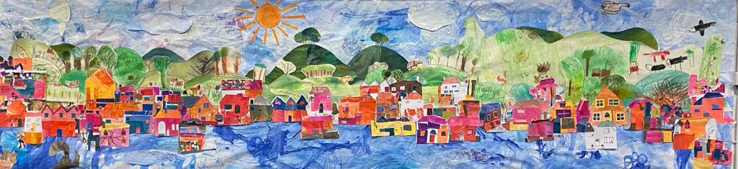

Show our love through kindness, determination and curiosity; strengthening ourselves and our community

Welcome Back
Welcome back to the start of another school year. I hope you all had a wonderful summer and were able to enjoy some quality time with family and friends. It has been lovely to see children returning to school with such enthusiasm, and we are excited for all that the year ahead has in store.
A particularly warm welcome goes to all of our new families. This includes the children starting with us in Reception, as well as those joining us in other year groups. We are delighted that you have become part of our school community and look forward to getting to know you over the coming weeks and months.
We are also delighted to welcome Mr Bruno to our staff team as the teacher of Birch Class. We know he will be a great addition to our school community, and I am sure you will join us in making him feel very welcome.
It has been a real pleasure to spend time in classrooms over the first few days of term. The children have made a positive start to the year, settling quickly into new routines and making the most of the opportunities that a new school year brings. Already, classrooms are busy with learning and laughter, and it has been wonderful to see children showing our school values of kindness, determination and curiosity, helping to make our school a happy and positive place to learn.
In assembly today, we reacquainted ourselves with the story of the Good Samaritan and reflected on what it teaches us about showing kindness to others. Together, we explored how this links to our school values and how we can demonstrate kindness, determination and curiosity through our everyday actions, both in and beyond school.

Meet the Team and Open Classroom Event
We would like to invite you to our Meet the Team and Open Classroom Event on Wednesday 16th September at 5.00pm.
This event replaces our traditional curriculum-focused Meet the Teacher sessions and offers an opportunity to meet the staff who work with your child, put faces to names and hear about key whole-school routines and expectations.
We will begin together in the hall before inviting families to visit classrooms, see where children learn each day and spend time meeting teachers and support staff. We hope this informal event will provide a valuable opportunity to strengthen the partnership between home and school and help ensure a positive start to the year for both children and families.
Following feedback from in last year’s parent survey, we are keen to provide more opportunities for families to understand what children are learning in school. This event is the first of many opportunities throughout the year to find out more about your child's learning and development, and we very much hope that you will be able to join us.
Thank you for your continued support as we begin another exciting year together.
Miss Clarke
Attendance

Regular attendance is vital to your child's success at school. Every day brings valuable opportunities for learning, developing friendships, building confidence and being part of our school community. While occasional absence due to illness is sometimes unavoidable, every day missed can mean missed learning and experiences that are difficult to replace. We ask all families to support good attendance by ensuring children attend school every day they can and arrive on time, ready to learn.
Every day counts.

If you are not sure if your child is well enough to come to school please check the following guidance: Is my child too ill for school? - NHS

This Week’s Learning

Acorn Class:
The children have had a great start settling into school, and we are incredibly proud of how confidently they have embraced their new surroundings. Mrs Beeton, Mrs Humphries and Miss Brown are so proud of each and every one of them. It has been wonderful to see how happy and excited they have been as they explore their new environment, make new friends and discover all the fun and learning that school has to offer! Well done Acorn Class!
Mrs Beeton & Mrs Humphries

Birch Class:
In Birch class we've had a great start to the year, welcoming a number of new children from reception as well as returning year twos. We have spent some time getting to grips with the KS1 learning environment, and its rhythms, routines and expectations. We have considered the meaning of our school values and how we can show them day by day. We have also had a lot of fun composing self-portraits, drawing our summer holidays and colouring all the emotions we will come across at school.
Mr Bruno

Pine Class:
The children have had a lovely start to the new school year in Pine Class. It has been wonderful to see them reunited with their friends and eagerly chatting about their summer holidays. I have also really enjoyed getting to know the Year 3 children. Over the past two days, we have been introducing our class routines and expectations for the year ahead, as well as exploring some of the exciting topics and learning opportunities we will be focusing on in the coming weeks. Next week we have an exciting science workshop and our first swimming lesson to look forward to.
Mrs McNamee
Oak Class:
This week Oak class have shown their maturity and determination to rise to the challenge of being in upper key stage 2. We have explored our writing text, 'Into the forest' using the illustrations to support the storytelling and enjoyed making inferences based on clues in our Reading lesson. In Maths, the children have been pulling on prior knowledge to understand place value and use formal method of addition.
It has been lovely to see the children be so welcoming, friendly and confident within their new classroom and the wider school during playtimes.
Mrs Greenway and Miss Clarke

