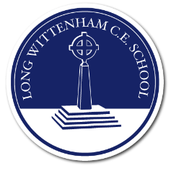
At Long Wittenham School we show our love through kindness, determination and curiosity; strengthening ourselves and our community.

‘…. with all your heart and with all your soul and with all your strength and with all your mind’ Luke 10:27

Acorn Class
Spring 1 2026

Big Questions  What can we learn from stories?  What do they tell us about the past?  What do they tell us about the world we live in?  What can we learn from the actions of story characters?  What changes occur in Winter?  What is ice and where does it come from?  How do animals survive in Winter? | 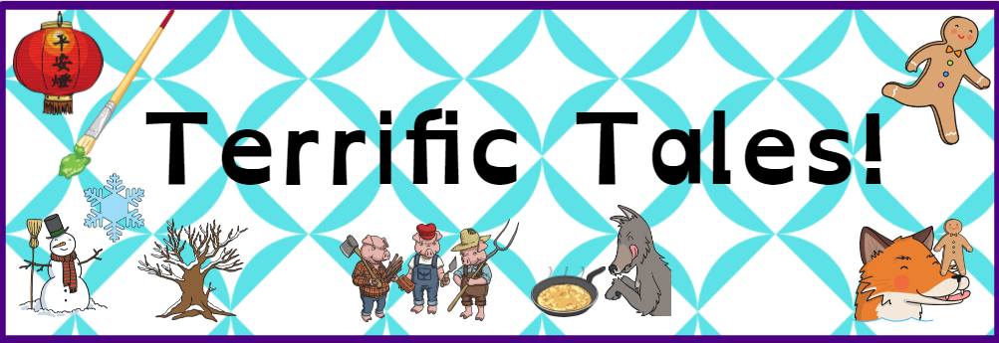  This term we will be basing all of our learning around stories, including traditional tales that have told for many generations. We will become story tellers as we learn to retell these traditional stories and become actors as we take on the role of different characters. We will explore different story settings as we learn about the differences between the countryside and towns and cities as well as reading stories set in the past and comparing them to the present. | Meaningful Experiences  We will spend a morning exploring the different landscapes around Long Wittenham and create our own sketches of what we see as part of our work on story settings.  During Forest School we will be exploring the changing seasons and seeing first-hand the impact that winter has on the countryside surrounding Long Wittenham.  We will have the opportunity to cook throughout the term including making gingerbread and pancakes.

Spring 1
Communication and Language | Personal, social and emotional development | Physical Development | Literacy
To develop our communication and language skills we will:  - Listen to a range of traditional tales identifying the key features of this type of story.  - Use what we know about traditional tales to make predictions.  - Begin to learn the skill of inference as we think about how different characters may be feeling and why they have acted in a certain way.  - Retell these stories in a range of ways including using puppets, masks and  - Join in with and recite simple songs and rhymes.  - Explore the meaning of new words and use in everyday contexts.  We will have a whole class focus on developing an awareness of correct speech sounds and patterns of speech so that we can articulate ourselves clearly.  Each week will focus on a new story. These will underpin our learning in communication and language as well as literacy.  Week 1: The First Day of Winter  Week 2: The Gingerbread Man  Week 3: The Piano and the bear  Week 4: The house that once was  Week 5: Mr Wolf’s Pancakes  Mr Wolf’s pancakes includes a range of characters from other traditional tales so we will also read the stories that they are originate from. | To develop our personal, social and emotional skills we will:  - Continue to talk about sharing, taking turns and showing kindness to all members of our class.  - Develop strategies to regulate our own emotions without the support of an adult.  - Have lots of opportunities to share both our achievements and challenges to develop resilience.  - Begin to explore metacognition (learning to learn skills) by exploring the mantra ‘I can’t do it yet’ and what having a growth mindset means.  In our SCARF circle times we will be exploring the theme entitled ‘Keeping Safe’. Each week will consider different parts of this theme as follows:  - What's safe to go onto my body  - Keeping Myself Safe - What's safe to go into my body (including medicines)  - Safe indoors and outdoors  - Listening to my feelings  - Keeping safe online  - People who help to keep me safe | To develop our physical skills we will:  - Continue to work on developing a secure and comfortable pencil grip, working towards using a tripod grip, by drawing pictures and diagrams during our play.  - Practise using scissors with greater precision and control by cutting straight lines, curved lines and circles.  - Follow our interest in ball games whilst we are learning independently by having access to range of ball sizes and types so that we can create our own games.  We will continue to follow a structured letter formation programme to support with our handwriting.  This term we will learn to form ‘curly Caterpillar letters’ – c, a, d, e, s and g.  These letters all require anti-clockwise movements so we will also be working on the pre-handwriting skills of circles, arches and spirals.  In our P.E lessons we will be working on our fundamental movement skills and Gymnastics. In Gymnastics we will be focussing on creating different shapes with our bodies e.g. star, straight and tuck. We will explore these on mats first followed by low apparatus and high apparatus. In Real P.E we will be exploring static and dynamic balance. | To develop our Literacy skills we will:  - Learn what nouns and adjectives are by creating word banks when exploring the characters and settings in our stories.  - Use this knowledge to label pictures and write captions.  - Continue to work on our segmenting skills ensuring we hear and include the initial, middle and final sounds in more complex words.  - Begin to write simple sentences remembering to leave spaces between each word and to include a full stop at the end of a sentence.  We will do this by writing for different purpose such as writing instructions, recipes and speech bubbles.  In Phonics we will:  Learn the digraphs:  ai ee igh oa oo oo ar or ur ow oi ear air er  Read longer words containing double letters such as rabbit and ladder.  Learn to read the tricky words:  was you they my by all are sure pure  We will also be revisiting the tricky words we covered last term.  As we learn each sound, it will be added to your child’s sound book to practise at home.
Maths | Understanding the World | Expressive arts and design | How can you help at home?
In maths we will continue to make steps towards developing a deep understanding of the numbers to ten employing the mantra ‘not big numbers but big thinking’  To do this we will:  - continue to develop our subitising and counting skills as well as exploring the composition of numbers within and beyond 5  - connect quantities with numerals so that we recognise numbers to 10  - begin to identify missing parts for numbers within 5  - explore the structure of the numbers 6 and 7 as ‘5 and a bit’ and connect this  to finger patterns and the Hungarian  number frame  - focus on equal and unequal groups  when comparing numbers and understand that two equal groups can be called a ‘double’  - sort odd and even numbers according to their ‘shape’  - continue to develop our understanding of the counting sequence and link cardinality and ordinality through the ‘staircase’ pattern  - order numbers and play track games  - join in with verbal counts beyond 20, hearing the repeated pattern within the counting numbers. | Understanding the world encompasses three key areas and this term we will be exploring all of these.  The Natural World  We will be continuing to learn about the effect the changing seasons have on the natural world by exploring changes seen in Winter. This will involve exploring how animals survive during the winter months as well as having the opportunity to observe natural processes first hand such as the creation of ice and watching it melt. We will be exploring materials and their properties by carrying out a number of investigations related to stories we are reading. We will be making a bridge to help the gingerbread man, a raft for the three billy goats gruff and the strongest house for the three little pigs.  Past and Present  Whilst reading our focus stories this term, we will begin to notice and comment on images of familiar situations in the past as well as comparing and contrasting characters from stories, including figures from the past. This is the starting point for developing historical enquiry skills as we learn to question what we see and comment on the differences seen.  People, Culture and communities  In addition to looking at how the past is depicted in stories, we will explore stories that take place in different settings and compare this to what we know about our own community. In R.E we will be exploring the key questions, who are Christians and what do they believe? | This term we will be focussing on the artistic skill of printing.  To develop our skills in this area we will:  - Explore the patterns we can create using pre-prepared printing blocks and rollers  - Explore how we can print using natural materials.  - Design and make our own printing block using string and cardboard.  We will use our design skills during our science experiments this term whilst making bridges and rafts as well as using our artistic skills as we paint winter trees.  In music this term we will be learning to sing two songs, the cuckoo polka and shake my sillies out. We will explore:  - Pulse and beat  - Changes in tempo  - Vocal play and sound stories  - Movement to music  We will also be exploring different percussion instruments as we learn to play musical instruments to accompany each song. | Share your child’s phonics book with your child to support them to recognise the sounds that they are learning in class.  Share your child’s reading practice book with them daily allowing them to develop their confidence and fluency.  Read a range of books that depict different characters and settings. Talk about what your child notices about the story. Is it set in the past or the present? Is the setting familiar to them or a place they have never encountered before?  Support your child to complete their first homework project. This project will extend and expand upon the themes we are covering in class.

