Pine Class LKS2
Autumn 2
English |  | Maths | Science
Reading and Writing | Phonics and Spelling | Maths | Science
Habitats by Hannah Pang  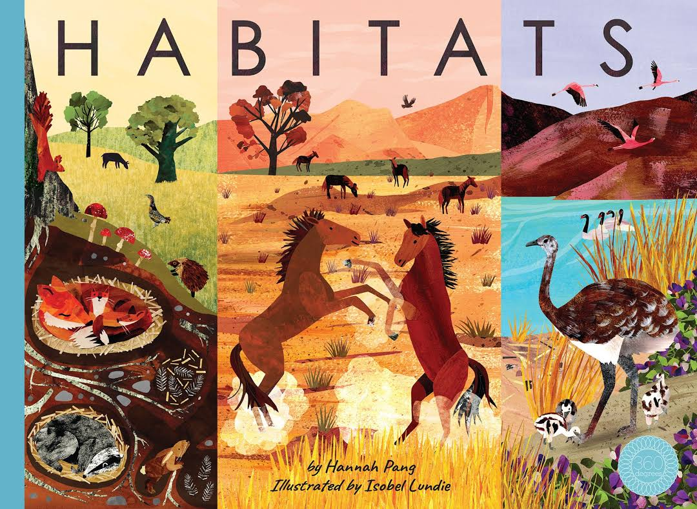  Children will write a description of their own habitat.  The Iron Man by Ted Hughes  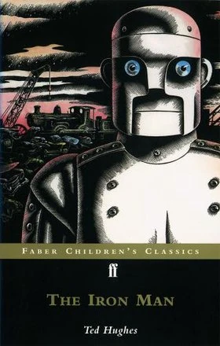  Children will read this book and discuss various comprehension aspects.  Children will write a story about the Iron Man’s origins.  Children will write a recipe. | Children will continue learning the year 3 & 4 key spellings as well as high frequency words. | This term builds on the foundations from Term One, with continued focus on multiplication and division, before moving into area and length and perimeter. Pupils will learn to recall and use multiplication facts up to 12 × 12, use written methods for multiplication and division, and solve problems using these skills. In geometry, they will calculate the area of shapes by counting squares and measuring the perimeter of rectangles and compound shapes. Children will also be encouraged to reason about relationships between operations and check their answers using estimation. | Science – Materials: States of Matter  In science, pupils will explore the different states of matter — solids, liquids, and gases — and investigate how materials change state when they are heated or cooled. They will learn that temperature can affect these changes and measure it using thermometers. Through hands-on investigations, children will observe condensation and evaporation, linking these processes to the water cycle. They will also classify materials according to their state and use scientific vocabulary to describe their observations, developing their ability to ask questions, record results, and explain findings clearly.

R.E | History | DT | Music
RE this term focuses on How does the worldwide Christian family celebrate, worship, and mark key events? Pupils will learn how Christians around the world observe festivals such as Christmas and Easter, and explore similarities and differences in worship and traditions. They will consider the importance of these celebrations to believers and reflect on how shared events can bring communities together. | Our history topic is Ancient Egypt. Pupils will explore the achievements and everyday life of this civilisation, learning about farming, religion, and the role of the pharaohs. They will place Ancient Egypt within a broader historical timeline and use evidence from artefacts and sources to build their understanding of the past. | DT this term will focus on pneumatics. Pupils will explore how air can create movement, then design and build their own pneumatic models. They will test and refine their creations, evaluating how well they meet design criteria. | Music lessons will explore rhythm, pattern, and tone through The Pink Panther Theme and Composing with Colour. Pupils will listen carefully to identify tempo and instrumentation, and they will experiment with layering sounds and composing short musical sequences. They will also learn to read simple rhythmic notation and perform in small groups with increasing control.
P.E | PSHE | Computing | French
In PE, pupils will continue their swimming lessons, aiming to improve their stamina, confidence, and stroke technique across a range of styles. They will also learn essential water safety and self-rescue skills. Alongside swimming, pupils will take part in Real Gym Unit 3, developing flexibility, balance, and coordination through creative movement sequences and apparatus work. The focus will be on control, strength, and collaboration when performing routines. | This term’s PSHE theme is Valuing Difference. Pupils will explore what makes each person unique and discuss how to recognise and respect similarities and differences between people. They will learn about inclusion, empathy, and fairness, considering how to respond positively to conflict and discrimination. Activities will help pupils understand the importance of kindness, equality, and teamwork in their school community. | In computing, pupils will learn about online safety, understanding how to use the internet responsibly and protect personal information. They will discuss the importance of respectful online communication and how to recognise and respond to unsafe situations. Later in the term, pupils will begin working with spreadsheets, learning to input, organise, and interpret data for simple calculations and charts. | In French, pupils will build on their learning from Term One by revising greetings and introducing vocabulary for colours, numbers, and age. They will practise asking and answering questions such as “Quel âge as-tu?” (“How old are you?”) and use colours to describe objects and classroom items. Emphasis will be placed on pronunciation and listening comprehension through songs and interactive activities.

